CHAPTER 1
INTRODUCTION
Process mining is a technique designed to discover, monitor, and improve real processes (i.e., not assumed processes) by extracting readily available knowledge from the event logs of information systems.
Process mining applies data science to discover, validate and improve workflows. By combining data mining and process analytics, organizations can mine log data from their information systems to understand the performance of their processes, revealing bottlenecks and other areas of improvement. Process mining leverages a data-driven approach to process optimization, allowing managers to remain objective in their decision-making around resource allocation for existing processes.
Information systems, such as Enterprise Resource Planning (ERP) or Customer Relationship Management (CRM) tools, provide an audit trail of processes with their respective log data. Process mining utilizes this data from IT systems to create a process model, or process graph. From here, the end-to-end process is examined, and the details of it and any variations are outlined. Specialized algorithms can also provide insight into the root causes of deviations from the norm.
Process mining focuses on different perspectives, such as control-flow, organizational, case, and time. While much of the work around process mining focuses on the sequence of activities i.e., control-flow the other perspectives also provide valuable information for management teams.
1.1 History of Process Mining
This specialized algorithm for identifying data trends, patterns, and inefficiencies from event logs started to take form in the late 1990s. A Dutch computer scientist and professor, Wil van der Aalst, is the face behind the academic research that went into discovering the details of how a process unfolds.
Also known as the godfather of process mining, van der Aalst and his team of researchers encountered a resolution to utilize data in assortment with analytics and visualization tools.
However, the study remained limited to the academic world for quite some time. Eventually, businesses realized that merging process mapping with data analysis could deliver the most efficient results. Around this time, process mining’s economic prospects became known across industries.
Of course, modern process mining software solutions are much more advanced for competing in today's business world. They bring an amalgamation of data science, data mining, business intelligence, and analytics to deep dive into the workings of an organizational model.
As a result, the newer wave of process mining not only visualizes and optimizes processes but also measures KPIs, benchmark and compare operations, collaborate with your existing IT infrastructure, and solve problems with data-centric solutions.
1.2 Process
A process is very simply a series of linked actions or steps taken to achieve a particular end. It is a series of actions taken from start to finish to complete an activity. In process mining, this set of actions can be individual steps or tasks that define a business operation's start and end points. Processes can be one-time, recurring, or periodic, depending on the nature of the workflow. For customer service, these could be the steps to resolve a ticket.
- For sales, it could be the steps to progress an opportunity from a lead to closure.
- Take order management, for example, this could be the steps from a customer ordering goods, to you shipping, and then ultimately getting paid for them.
1.3 Process Mining
Process Mining is the combination of two disciplines: Data Science and Business Process Management. Process Mining essentially uses Data Science techniques, such as Big Data and AI, to address Process Science problems such as process improvement and automation (cf. van der Aalst 2016)
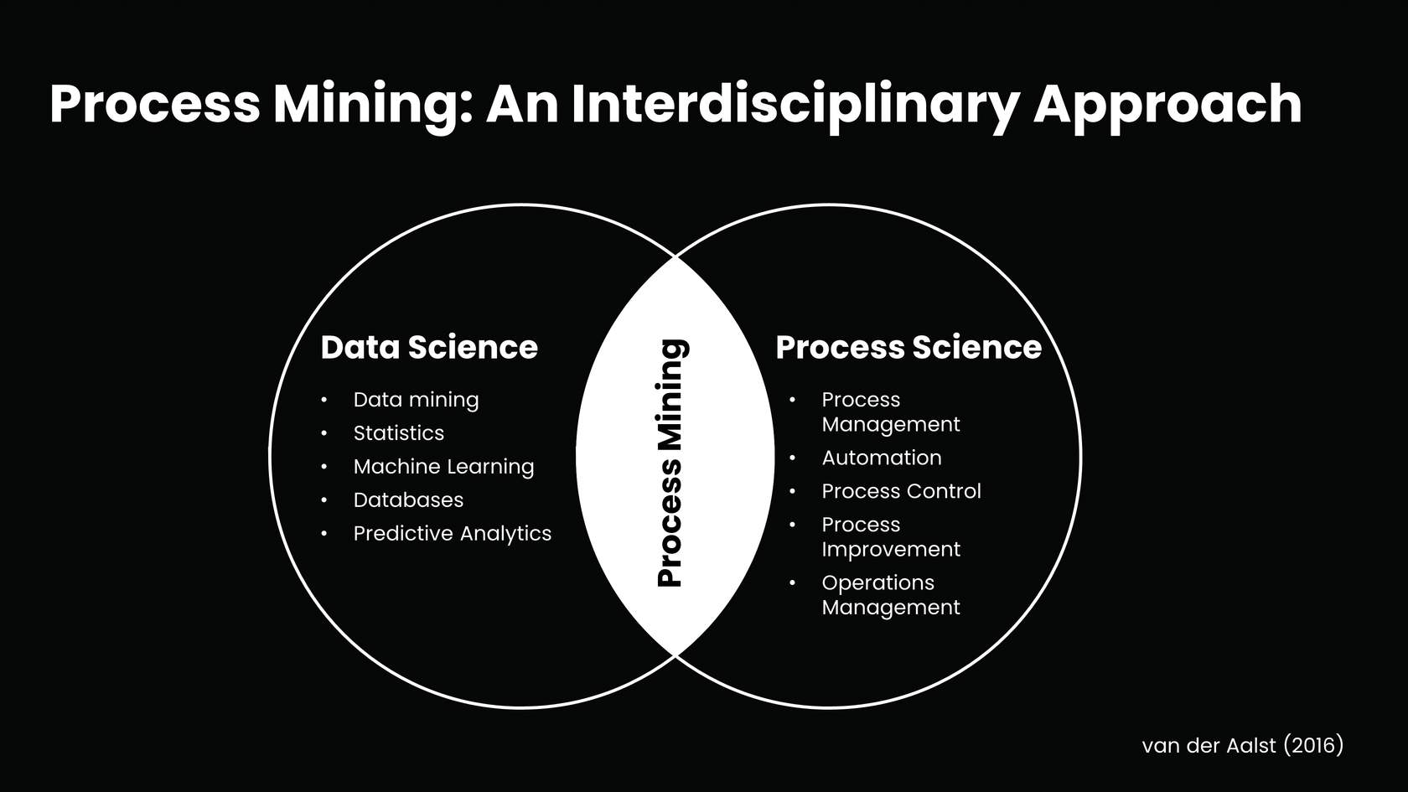
Fig. No 1.1 Process Mining
Process Mining achieves this union by taking the digital footprints that are created in IT systems and using them to reconstruct and visualize process flows. From here, Process Mining technology can identify patterns and deviations and ultimately eliminate bottlenecks. Now we will take a deeper look at what is required to reconstruct a process in this way.
Process mining includes:
- Automated process discovery (extracting process models from an event log)
- Conformance checking (monitoring deviations by comparing model and log)
- Social network/organizational mining
- Automated construction of simulation models
- Model extension
- Model repair
- Case prediction
- History-based recommendations
1.4 Process Mining Importance
Increasing sales is not the only way to generate revenue. Six sigma and lean methodologies also demonstrate how the reduction of operational costs can also increase your return-on-investment (ROI). Process mining helps businesses reduce these costs by quantifying the inefficiencies in their operational models, allowing leaders to make objective decisions about resource allocation. The discovery of these bottlenecks can not only reduce costs and expedite process improvement, but it can also drive more innovation, quality, and better customer retention. However, since process mining is still a relatively new discipline, it still has some hurdles to overcome. Some of those challenges include:
- Data Quality: Finding, merging, and cleaning data is usually required to enable process mining. Data might be distributed over various data sources. It can also be incomplete or contain different labels or levels of granularity. Accounting for these differences will be important to the information that a process model yields.
- Concept drift: Sometimes processes change as they are being analysed, resulting in concept drift.
Process mining sits at the intersection of business process management (BPM) and data mining. While process mining and data mining both work with data, the scope of each dataset differs. Process mining specifically uses event log data to generate process models which can be used to discover, compare, or enhance a given process. The scope of data mining is much broader, and it extends to a variety of data sets. It is used to observe and predict behaviors, having applications within customer churn, fraud detection, and market basket analysis to name a few.
Process mining takes a more data-driven approach to BPM, which has historically been managed more manually. BPM generally collects data more informally through workshops and interviews, and then uses software to document that workflow as a process map. Since the data that informs these process maps is more qualitative, process mining brings a more quantitative approach to a process problem, detailing the actual process through event data.

CHAPTER 2
PROCESS MINING TECHNIQUES
Process mining techniques benefit companies of any size and workflow. Process mining solutions can focus on various elements like the flow of a process, the organizational or time management with data mining and machine learning integration.
There are three main classes of process mining techniques:
- Process Discovery
- Conformance Check
- Analysis and Enhancement

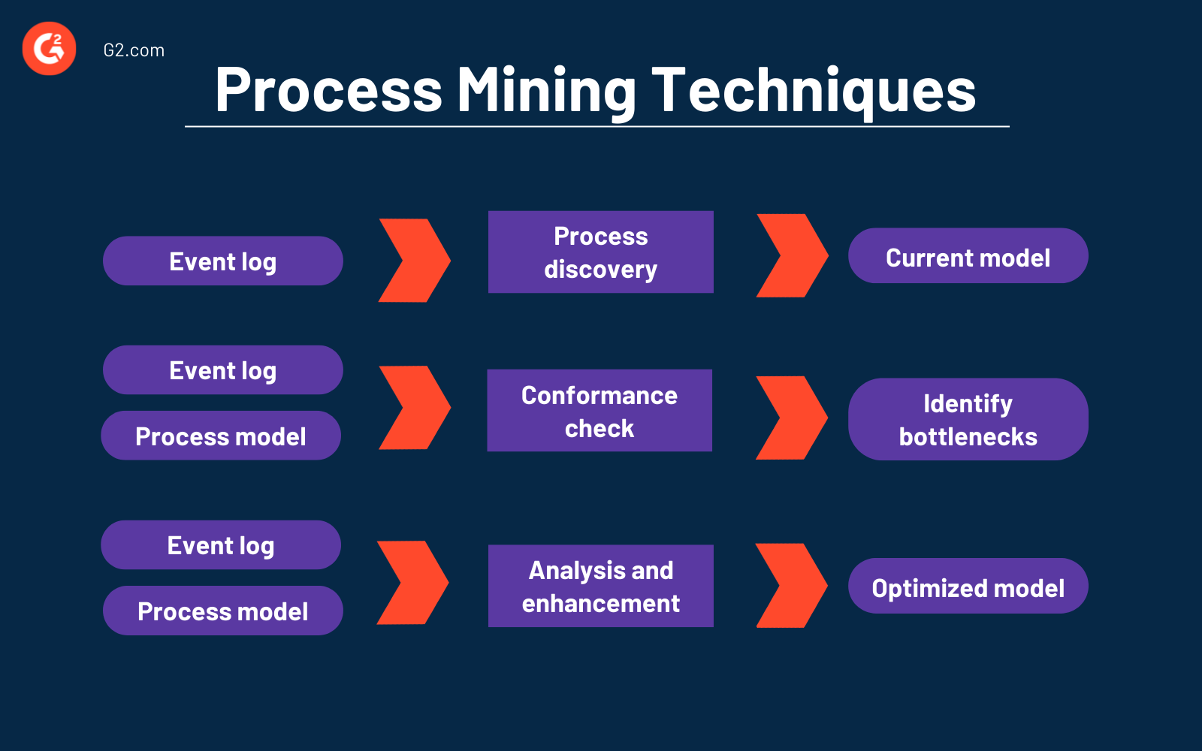
Fig. No 2.1 Process Mining Techniques
2.1 Process Discovery
Process discovery uses event log data to create a process model without outside influence. Under this classification, no previous process models would exist to inform the development of a new process model. This type of process mining is the most widely adopted.
During discovery, process mining software traces the entire business workflow from end to end and provides an ideal blueprint to its users. As the name suggests, automated business process discovery (ABPD) automates this process discovery stage by incorporating artificial intelligence (AI), computer vision, and computational logic.
These automated solutions use a discovery algorithm to extract data based on user interactions from IT systems, event logs, and databases. Then, it analyzes the accumulated data to identify patterns and process models. Finally, ABPD draws out the organization's collective operational processes with real-time monitoring and highlights any significant process deviations.

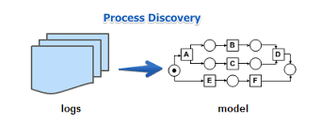
Fig. No 2.2 Process Discovery

Business process discovery is a process mining technique used to create a data-based visualization of process workflows. Using data found in event logs, process mining automatically generates a discovered model for analysis, giving users a visual and unbiased representation of their business processes. The primary goal of process discovery is to increase transparency and process knowledge for enhancement.
Process discovery involves these steps:
- Checking for availability of data points.
- Extracting and transforming data.
- Importing data into the process mining system.
- Generating a visualization of the discovered process, or process model.
2.1.1 Benefits of Process Discovery
Process discovery gives transparency into the health of tasks, workflows, and end-to-end processes across a business unit or organization.
- Identified inefficiencies: With process discovery, organizations can easily identify bottlenecks, process deviations, and other inefficiencies. This insight allows them to act and make improvements that can lead to greater efficiency and cost savings.
- Data-driven insights: Process discovery uses data to provide objective insights into how a business process is functioning. This helps to remove any subjective biases that may be present when analysing a process manually, leading to more accurate conclusions and recommendations.
- Fast analysis: Compared to manual analysis, process discovery with process mining is often much faster. This means that companies can identify inefficiencies and opportunities for improvement in a shorter amount of time, allowing them to act and see results sooner.
- Collaboration: Process discovery involves stakeholders from across the organization, leading to greater collaboration and a shared understanding of the process. This can help break down silos and improve communication between teams.
- Compliance: By understanding a business process in detail, organizations can ensure they are following regulations and guidelines more effectively. This can lead to reduced risk and better compliance outcomes.
- Agility: By identifying inefficiencies and opportunities for improvement, companies can make changes to their processes more quickly and efficiently, allowing them to adapt to changing business needs and stay ahead of the competition.
2.2 Conformance Check
Conformance checking confirms if the intended process model is reflected in practice. This type of process mining compares a process description to an existing process model based on its event log data, identifying any deviations from the intended model.
Once the operational model is evident from the discovery algorithm, it is possible to find that the process execution deviates from the ideal process model. That is why you need conformance checking in organizational mining to help determine a process' compliance rate. processes are visualized using event logs. This visualization is also referred to as the discovered model.
This method systematically evaluates the current process flow and compares event logs with the reference or target models. Conformance check assists in discovering and correcting any inefficiencies that might occur in the execution of the ongoing processes by measuring their performance against the ideal performance requirements.

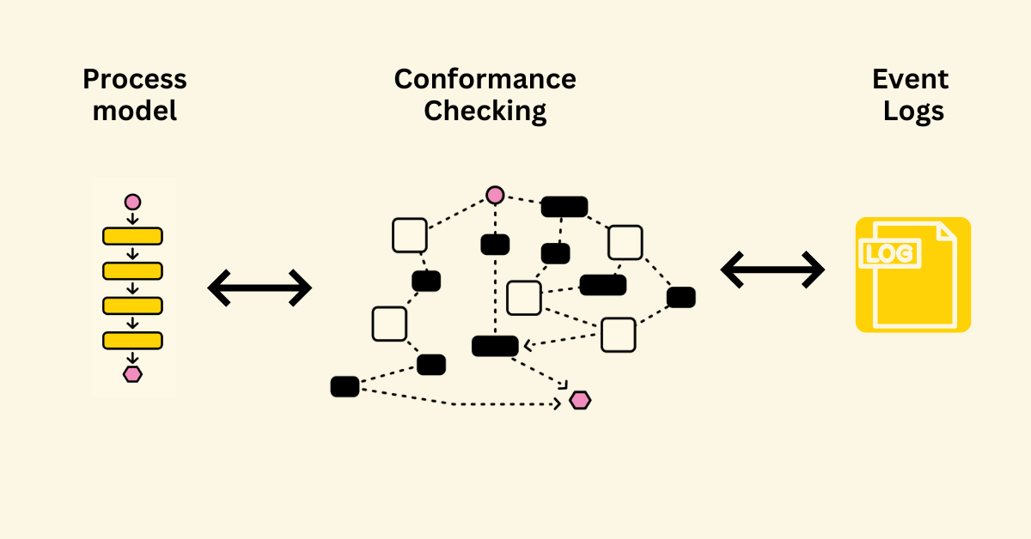
Fig. No 2.3 Conformance Checking Relates to Process Mining

Conformance checking is a technique used to check process compliance by comparing event logs for a discovered process with the existing reference model (target model) of the same process. This technique is used to determine whether the target process corresponds to the actual process, highlighting deviations between the two.
2.3 Analysis and Enhancement
This type of process mining has also been referred to as extension, organizational mining, or performance mining. In this class of process mining, additional information is used to improve an existing process model. For example, the output of conformance checking can assist in identifying bottlenecks within a process model, allowing managers to optimize an existing process.
Once you have the necessary information on the current process deficiencies from process discovery and conformance checks like bottlenecks, process loops, and unwanted deviations, you can narrow down the steps that have the potential to be optimized to the highest standard.
Therefore, the objective behind the model analysis and enhancement is to determine how to optimize the target process model to its optimum potential. The enhanced model minimizes the risk of existing bottlenecks, making the overall process more efficient with automated workflow.
Process enhancement, sometimes referred to as model enhancement, is a process mining technique that’s used to extend or enhance a target model or reference model using discovered information about the actual process. For example, analysis may uncover bottlenecks or unplanned process sequences that can be eliminated from the model to make it a better representation of the ideal process.

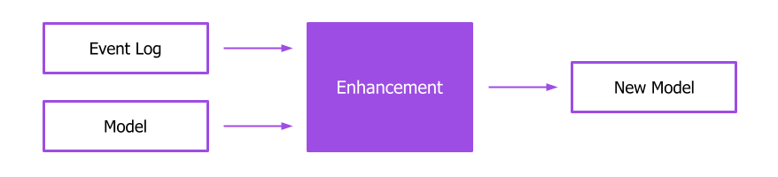
Fig. No 2.4 Process Enhancement

The results of the process enhancement serve as the reference point for future analysis with process discovery and conformance checking. Correctly implementing identified optimization potential is critical. Making the wrong changes, or unfavorable changes, can be costly, resulting in higher expenses, rule violations, or quality defects.
steps in process enhancement:
- Analyse the process data.
- Identify optimization potentials (process discovery, conformance checking).
- Adapt the target process model (process enhancement).
- Implement the target process model.
- Check the new process implementation based on the analysis of the process data (continuous improvement process).
Suppose you perform a process mining analysis with the log file of a business process. Using the process discovery and conformance checking methods, you identify various process weaknesses, including bottlenecks, process loops, and unwanted process deviations. This is all valuable information. Now you know where to find which types of optimization potential.
But what do you do with this knowledge? You specifically adapt your target model, which serves as the standard guideline for process implementation. This means that you change the process in such a way that the risk of bottlenecks is reduced, or certain process sequences are no longer possible. The success or usefulness of the process changes can only be determined after the new process has been implemented for some time. Therefore, process mining is an excellent way to continuously improve your process.

CHAPTER 3
APPLICATIONS
Applications of process mining involve using process mining techniques to analyze and improve processes as they occur, providing insights and interventions in real-time. Here are some examples of real-time applications of process mining:
- Operational Monitoring and Alerts: Process mining can be used to monitor ongoing processes in real-time and generate alerts when deviations or anomalies are detected. This allows organizations to take immediate action to address issues and maintain process efficiency.
- Dynamic Resource Allocation: In scenarios where resources need to be allocated dynamically, such as in manufacturing or service industries, real-time process mining can help optimize resource allocation based on the current state of the process and demand.
- Customer Support and Service: Real-time process mining can analyse customer support interactions and service processes as they happen. It helps identify areas where customer queries are getting delayed, allowing support teams to intervene promptly and provide timely assistance.
- Supply Chain Visibility: Monitoring supply chain processes in real-time using process mining can provide visibility into the movement of goods, inventory levels, and potential disruptions. This enables organizations to respond quickly to changes in demand or supply.
- Healthcare Patient Pathway Optimization: In healthcare settings, real-time process mining can analyse patient pathways, identify delays, and optimize the allocation of medical resources to ensure timely patient care.
- Energy Management: Real-time process mining can be applied to monitor energy consumption patterns in buildings or industrial processes. It helps in identifying energy wastage and suggesting real-time adjustments to optimize energy usage.
- Fraud Prevention: In financial transactions, real-time process mining can detect unusual patterns or behaviours that might indicate fraudulent activities. Immediate alerts can be triggered for further investigation.
- IT Incident Management: Real-time process mining can be employed to monitor IT incidents and responses in real-time. This ensures that IT teams can quickly address and resolve issues to minimize service disruptions.
- Logistics and Transportation Optimization: For logistics and transportation companies, real-time process mining can track the movement of goods, optimize routes, and adapt to changing conditions on the road for efficient deliveries.
- Emergency Response Management: During emergency situations or crisis events, real-time process mining can help organizations manage response processes effectively by identifying bottlenecks, allocating resources, and adapting to changing conditions.
- Retail Operations: In retail, real-time process mining can track in-store customer movements, analyse checkout processes, and optimize staff allocation based on real-time foot traffic.
- Manufacturing Process Control: Real-time process mining can monitor manufacturing processes, identify deviations from optimal conditions, and trigger adjustments to maintain quality and efficiency.
These examples highlight how real-time process mining can provide valuable insights and enable organizations to make informed decisions and interventions on the fly, ultimately improving operational efficiency, customer satisfaction, and resource utilization.

CHAPTER 4
MODULES
4.1 Module 1: Introduction to Process Mining
Process Mining offers a data-driven and therefore more objective and holistic approach to understanding business processes. As a result, Process Mining has come to dominate a large majority of operational excellence, automation, and digitalization ambitions within industry.
Process Mining is the leading new technology when it comes to talking about algorithmic businesses - in other words, businesses that use algorithms and large amounts of real-time data to create business value. This has only become possible through the advent of information systems and administrative tools (e.g. Enterprise Resource Planning or Customer Relationship Management systems) which provide a good data source for process analytics.
Process Mining is a solution to costly and time-intense efforts to get data-driven insights into a business, as acknowledged by the industry research firm Gartner.

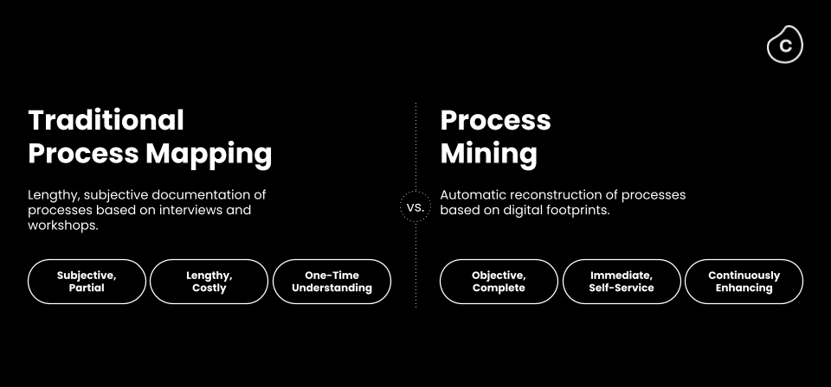
Fig. No 4.1 Traditional Process Mapping vs. Process Mining
Compared to the traditional process mapping approaches, Process Mining technology solves the complexity and visibility problem. Because it is using the system data in real-time, it provides a living, breathing view of the processes that is generated immediately and is always up-to-date, substantially reducing cost and the time to value.
It is an x-ray for businesses that gives 100% transparency into processes, eliminating process blind spots, and quantifying the impact of process problems on core KPIs.
It leverages data from a business’s source systems and user desktops to map the processes, thus eliminating conjecture about how they are running. This allows businesses to better field competing requests from their stakeholders because they can have confidence in the data.
4.1.1 Early Stages
Process Mining originally emerged from academic research into how event log data retrieved from Information Systems could be used to discover, monitor, and improve real processes. This real data can facilitate several aspects of Business Process Management including:
- Process discovery
- Conformance checking
- Organizational mining, i.e. using data to analyse the roles and people involved in a process
- Automation
- Simulation, i.e., foreseeing and testing the outcome of a process depending on the variation of variables
- Prediction
- History-based recommendations
4.1.2 Event Logs
Event Logs are the format in which we can retrieve our digital footprints from the underlying IT systems. They are essentially the logbooks that IT systems keep recording what events take place for each Case ID and at what time.
The Event Log information can be retrieved from several types of IT systems such as Enterprise Resource Planning (ERP), Supply Chain Management (SCM) or Customer Relationship Management (CRM) systems. These systems typically generate and store Event Log information in real time. Event Log information might also be retrieved in various situations and contexts from automated payment to customer journeys.
An Event Log contains each of the three key pieces of information that our digital footprints have:
- A Case ID: A unique identifier such as a purchase order item, invoice number or order number
- An Activity: The description of what has happened - for example, the creation of a purchase order or the receipt of goods
- Timestamp: The date and time that the activity took place
With these data points, you can reconstruct a process flow for a particular Case ID and aggregate the information across all Case IDs.
A process is very simply a series of linked actions or steps taken to achieve a particular end. For customer service, these could be the steps to resolve a ticket.
For sales, it could be the steps to progress an opportunity from a lead to closure Take order management, for example. This could be the steps from a customer ordering goods, to you shipping, and then ultimately getting paid for them.

4.2 Module 2: Process Mining Fundamentals
Process mining is an analytical discipline for discovering, monitoring, and improving processes as they are Process Mining works by extracting knowledge from event logs (also called digital footprints) readily available in today’s information systems, to visualize business processes and their every variation as they run. The Celonis Execution Management System (EMS) extends process mining by executing on insights automatically and orchestrating your existing technologies.
Some organizations spend their resources trying to reconstruct the process only to see pieces of the entire picture, and only at a certain point in time. Others use the digital footprints from their transactional systems to get an objective, real-time perspective on their process. Congrats, your organization is of the latter type!
When interacting with the dynamic visual representation and drilldown tools such as tables and charts, one can take an exploratory approach or a confirmatory approach.
- Exploratory Approach: An exploratory approach is one where you simply explore the data and see what value opportunities jump out at you. You are diving into the data without specific expectations and with an open mind. Analysis tools such as the Process Explorer, the Variant Explorer, and the Conformance checker are ideal for this.
- Confirmatory Approach: With the confirmatory approach, you are examining the data to see if it confirms or denies a hypothesis. Using your Celnois Analysis, specifically by filtering on attributes and using drilldown tables, you can find out whether the data confirms or denies that these perceived pain points exist and have a significant impact.
Beyond uncovering inefficiencies and their root causes using Celnois Analysis, our customers choose to use Celnois tools such as Action Flows (process automation) and Celonis Apps to maximize their organization's performance capacity. In this sense, they do not stop at Process Mining and leverage all that the Celonis Execution Management System (EMS) has to offer.
- Process: A process is a series of linked steps taken to achieve a particular goal.
- Activity: An activity is a step that occurs in the process. Process activities are actions that initiate or terminate a process or take place during it. Each activity consists of one
or more tasks that together are a milestone in the process.
- Case: A case is an “item” or “object” you follow through the process. Even for the same business process, the case differs from company to company, depending on how granular they want to get.
4.2.1 Variant Explorer
As the name implies, using the Variant Explorer, you can discover all the process variants that is all the different ways the process flows in your organization. The Variant Explorer is one of the Analysis tools to help you take an "exploratory" approach to find out how your process is performing. Watch the video below for an overview.
In the images so far and in the guided tour, the Variant Explorer was set to the Case Frequency KPI. Represented by a number, a Key Performance Indicator (KPI) allows you to quickly assess how your process is performing.
- Case Frequency: case frequency KPI reflects the number of unique cases associated with an activity or connection. In a single variant, naturally, the number is the same across the activities and connections.

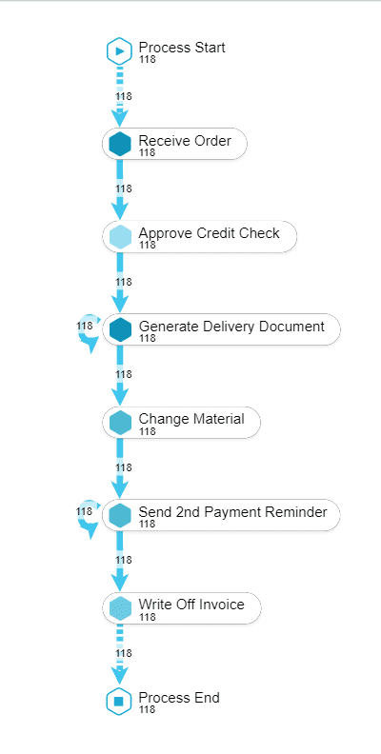
Fig. No 4.2 Case Frequency
Case Frequency shows 118 cases associated with this variant. Therefore, the count is the same across this entire single variant.
- Activity Freqeuncy: Activity Frequency shows how many times each activity occurred in total (236 times) for the 118 cases in the variant.

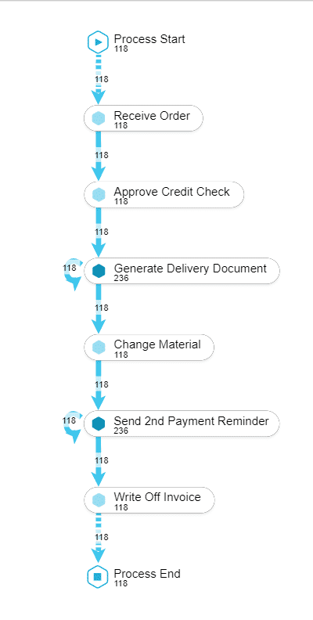
Fig. No 4.3 Activity Frequency

The activity frequency on "Generate Delivery Document" (236) is exactly double the case frequency (118); this reflects the fact that each case in this variant goes through "Generate Delivery Document" twice, as indicated by the loop. The same is true for the activity, "Send 2nd Payment Reminder."
Above is a side-by-side comparison of the same variant with Case Frequency and Activity Frequency KPIs. Notice the difference in the count for the "Generate Delivery Document" activity.
4.2.2 Process Explorer
The Process Explorer is another analysis tool to use when taking an exploratory approach. It is especially useful for quickly revealing activities beyond the most common ones. It also allows you to narrow your focus on a single activity, for example an undesired activity, to see which activities cases typically come from and which activities they are going to.
In the Process Explorer, if you display the Throughput Time KPI, you are looking at the time it took all the cases in the analysis to go directly between the two displayed activities. That is unlike in the Variant Explorer where the time is reflective of the cases in the variant or variants selected.
These metrics and KPIs are customizable by the person who creates the analysis. A common custom KPI is automation rate; that is the percentage of time when the activity was completed automatically and not manually.
4.2.3 Analysis Charts
A dimension is a category of attributes; for example, the dimension "customer name" is a category for individual customer names. Other examples of dimensions, depending on the nature of the process, can include vendor name, sales organization, region, and material group.
Key Performance Indicators (KPIs) are used to calculate and add aggregated values, for example, case count, order value, invoice value, throughput time, and automation rate.
In case you are a bit fuzzy on these concepts, do not worry, it'll get clearer as we look at dimensions and KPIs in a column chart and an OLAP table.

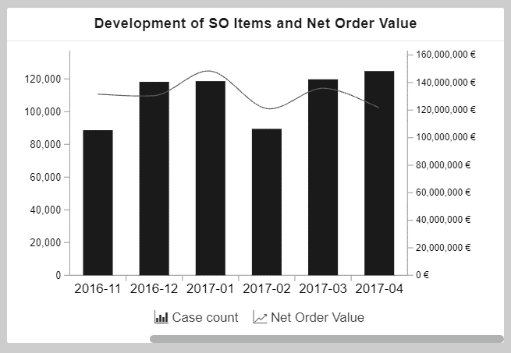
Fig. No 4.4 Development of SO items and Net Order Value
This chart shows the development of sales order items (KPI) and the corresponding net order value (KPI) over a period of time (dimension). The x-axis displays the dimension, the creation date of sales order, grouped by months.
The two y-axes display the KPIs: The columns display the number of sales order items (case count) and the line displays the net order value.This OLAP table is currently displaying three KPIs for all the sales organizations.
The first column displays the dimension, Sales Organization. The other three columns show KPIs: number of sales orders, average cycle time, and order value.
4.3 Module 3: Rising Star Technical
In the course of digitization, an increasing number of log data is recorded in IT systems of companies worldwide. This data is precious, as it represents how business processes are running inside a company. Process Mining comprises data-driven methods to discover, enhance and monitor processes based on such data. The heart of Process Mining are the Event Logs.
4.3.1 Celonis PQL
To gain valuable process insights, it is essential for Process Mining users to formalize their process questions as executable queries. For this purpose, we present the Celonis Process Query Language (Celonis PQL), which is:
- a domain-specific language
- tailored towards a particular process data model and
- designed for business users.
It translates process-related business questions into queries and executes them on a custom-built query engine, the Celonis PQL Engine.
4.3.2 Celonis Software Architecture
As you can observe in the graphic below, Celonis PQL is an integral component of the Celonis Software Architecture. All Celonis applications use this language to query data from a data model.
- Source System
- Data Model
- Data
- Celonis PQL Engine
- Applications
Metadata is data about the data or documentation about the information which is required by the users. In data warehousing, metadata is one of the essential aspects. Metadata is used for building, maintaining, managing, and using the data warehouses. Metadata allow users access to help understand the content and find data.

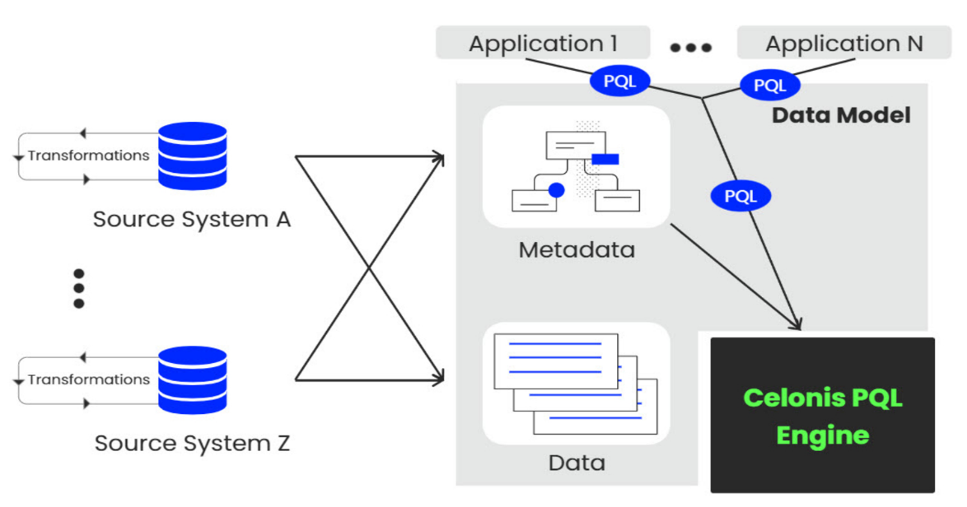
Fig. No 4.5 Celonis Software Architecture
4.3.3 PQL Queries
PQL can be written in a lot of different applications. You can apply it in Analyses, Knowledge Models, Action Flows and so on. But when it comes to writing queries, you shouldn’t be worried about visualization or design. You'd want to write a query, see its output and validate it to see if it is what you expect. And this is where the Data Explorer comes into play.
PQL is a declarative language that is based upon temporal logic. Temporal logic is an extension of traditional propositional logic with operators that refer to the behavior of systems over time. These behavioral operators, called predictes in PQL, provide PQL with a mathematically precise means for expressing properties about the relation between activities and events in process instances.
The design of the PQL language follows seven principles:
- Compactness: PQL queries should allow capturing intents in short, succinct programs that avoid ungrounded code redundancy.
- Decidability: PQL queries should be solvable by algorithms on a wide range of inputs.
- Efficiency: PQL queries should require reasonable and attainable amounts of computational resources.
- Expressiveness: PQL queries should allow describing many ideas.
- Intuitiveness: PQL queries should be easy-to-read and easy to comprehend.
- Portability: PQL queries should be independent of execution environments and data formats.
- Usefulness: PQL queries should allow fulfilling many practical tasks.
4.3.4 The P2P Process
P2P is the process of purchasing goods as a company. After creating a purchase order in the system containing information about the products and the vendor, the company receives the goods and pays the invoice from the vendor. As we want to analyze the process on a very granular level using Celonis PQL, the cases we are following through the process are purchase order items.
Activity table is structured, we see that for a given purchase order item number, there are different process steps/activities, such as creating the request, creating the item, receiving the goods and invoice. And every single process step has a corresponding event time. One of the earliest standard aggregation techniques you learned as a child was probably counting - for example, to express your age or how many matchbox cars you possess.
Taking the example of matchbox cars further, you might have wondered how many distinct types your car collection consists of and how many cars you owned per type on average. Since your cars could have attributes like size and price, you could have also described your collection in terms of the total monetary value your cars sum up to altogether.
You can easily map this intuitive example to what you can do with your data using the standard aggregation functions with Celonis PQL. Besides, counting, sum, distinct counting, and average, many more standard aggregations such as summary statistics (min, max, median, quartiles, standard deviation) await you.
4.3.5 Joins and Filters
The tables in a Data Model are connected via specific relationships to associate rows of one table with rows of another table. This is done using a foreign key. In general, these relationships can be classified as:
- One-to-many or 1:N
- One-to-one or 1:1
- Many-to-many or N:M
Depending on the number of rows of one table that can be matched with a row of another table. In Celonis Data Models only one-to-many (1:N) relationships are supported.
Every asset in Celonis has an underlying Data Model with multiple tables and 1:N relationships. The joins between those tables are left-outer joins, where the N-side is on the left.

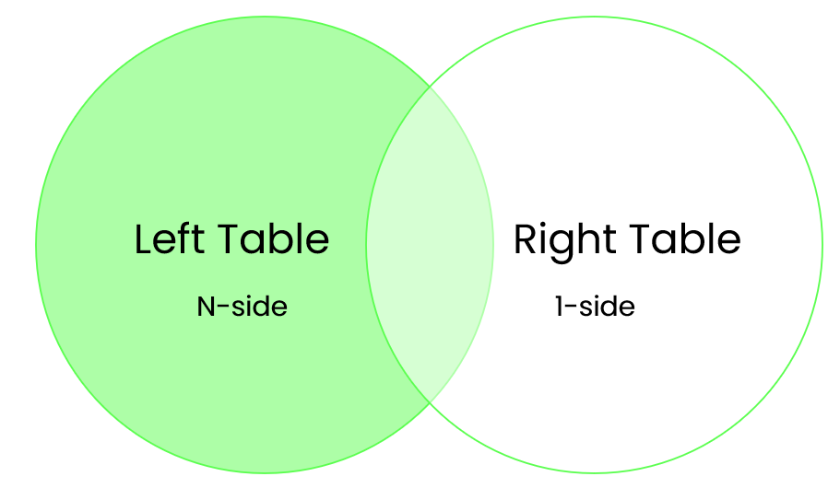
Fig. No 4.6 Left Join

When you write a PQL-query, all tables involved are pulled to a common table first, which means that the tables are joined implicitly. This has consequences, for example, in KPI calculation involving several tables. The common table is always the table on the most N-side.
Filters can be created on dashboards and used to modify the information displayed on all dashboards. With filters, you can create subsets of your data to have a closer look at particular parts of the process. Filters can be created from the header bar and the Filters panel.

4.3.6 Data Integration
As a data engineer or analyst working in Data Integration (formerly known as Event Collection), you’re responsible for bringing in clean, real-time process data into the EMS. In other words, you build the data pipeline.
Process Data is a set of connected activities with timestamps following one specific case, or object. Every activity is an "event" and your task is to collect these events and organize them in the right order.

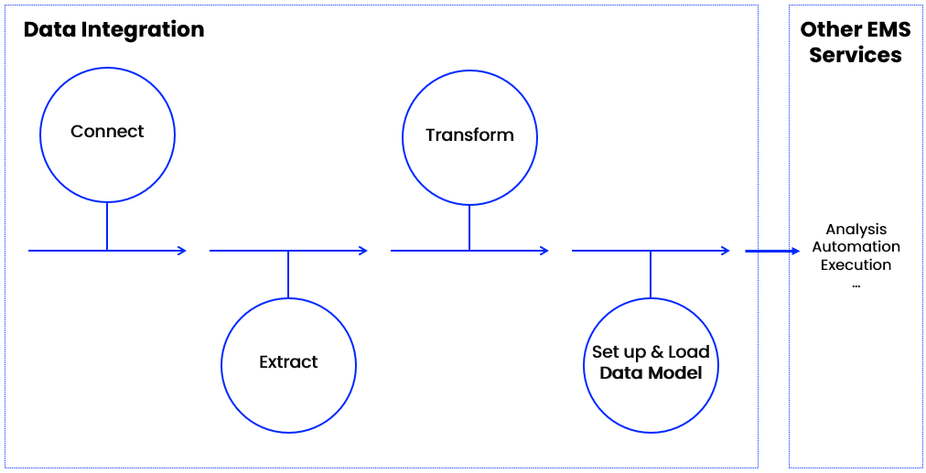
Fig. No 4.7 Data Model Built

Process Data is the data you’re after, but what does it take to get it into Celonis? Well, that’s precisely what Data Integration is for. It helps you connect to source systems, extract the relevant data, transform it to your needs, and load it into a polished Data Model. You can think of the Data Model as the fuel to all other work in your EMS. Once it’s ready, your team picks it up and can get started on analyzing it and acting on it.
- Process Connect: Connecting to source systems is your very first step to pull process data into the Celonis EMS. The EMS utilizes a broad set of technologies like message queues, Restful APIs, Soap APIs, direct database access, or system-specific solutions to connect.
- Extract Data: A full extraction is when you load entire source system tables into Celonis. It draws a fresh snapshot of source system tables and completely overwrites data you previously extracted. A delta extraction is when you do a partial load of the new or updated data from your source system. Note that delta extractions with Data Jobs rely on filters rather than change logs.
- Transform data: The goal is to transform your data so it can become a Process Data Model. Your most important task is to create the Activity table, also called the event log. This table is the basis for the Data Model you build to visualize your process flow.
- Data Model: It is the process of creating a visual representation of either a whole information system or parts of it to communicate connections between data points and structures.
- Execution Management System: An Execution Management System is typically associated with the financial industry, particularly in the context of trading. It is a specialized software platform that facilitates the execution of trades in financial markets. EMS platforms provide traders with tools to route orders, access market data, manage orders, and execute trades efficiently across multiple venues and asset classes.

CHAPTER 5
PROCESS MINING BENIFITS AND ITS USE CASES
5.1 Benefits
Process mining technology, businesses can improve their process intelligence to create ideal workflows and operations. As a result, more and more companies are leaning toward adopting this software to reach their maximum efficiency potential because process mining:
- Identifies process bottlenecks: Process mining tools empower businesses to identify process bottlenecks by discovering the causes of existing discrepancies.
- Enhances process intelligence: With the help of process mining software, organization stakeholders better understand processes, evaluate suggested fixes, and make smarter unified decisions based on data-backed insights.
- Improves business process management: Process mining is an integral part of BPM. Process mining work means owners can view processes in visual flows and automate tasks for higher efficiency.
- Increases transparency: Process mining serves as a guide to internal processes, allowing full disclosure about how functions carry out in a business workflow. This increased transparency makes it possible for decision-makers.
- Reduces expenses: Organizations can reduce operating costs drastically by identifying opportunities to automate tasks and fixing problem areas beforehand. It lets businesses analyse event log data and minimizes wasted time and resources.
- Offers superior customer service: Users can track process performance in real time by leveraging data procurement to identify bottlenecks and reach solutions much faster. As a result, businesses can improve their decision-making skills and deliver excellent support to their clients.
5.2 Use Cases
The potential of process mining is not limited to any specific industry or business model. Any enterprise that follows processes can use this, technology to reach maximum efficiency.
Process mining allows financial organizations to discover the possibility of automation
- Supply chain management: Process mining software analyzes logistical functions to pinpoint any weak links in a supply chain. Adopting an optimized model makes the supply chain more resilient to unexpected disorders.
- Finance: Automation and process enhancement significantly benefits the finance sector. Process mining can optimize audit controls, find root causes for incorrect invoices, mitigate risk, and enhance loan processes.
- Sales: Since complex sales processes depend on external factors, process mining allows business leaders to envision discrepancies and resolve them to meet fixed targets. Companies can increase conversion rates, enhance strategies, and improve sales performance across the board.
- IT & software: IT professionals benefit from sorting out disorganized engineering processes by gaining clarity and managing the complexity of ERP migrations and implementation. They can also monitor systems in real-time to ensure everything is running smoothly.
- Customer experience: With process mining technology, businesses can identify which customer processes are taking longer to resolve and pinpoint their root causes while providing solutions to fix the delay.
- E-commerce: Organization leaders in the e-commerce sector can boost their conversion rates by getting exclusive insights into buyer behavior, market trends, and growing customer base.
- Healthcare: The healthcare industry has a surplus of data, from health records to appointment booking procedures. Professionals can reconstruct this data digitally with process mining software for seamless integration.
- Education: Educational process mining (EPM) allows administrators to analyze and visualize students’ learning behavior by applying specialized algorithms. The student activity logs provide insights into tracking and monitoring their academic performance.

CHAPTER 6
LEARNING OUTCOMES
After completion of this training, we should be able to:
- Understand what Process Mining is and the basics of how it works.
- Summarize what an Event Log is and why we need it for Process Mining.
- Identify business use cases for Process Mining.
- Understanding how to discover, analyze, and improve business process using data driven techniques.
- To extract insights from event logs, identify bottlenecks, inefficiencies, and opportunities for optimization.
- To extract and create visual representation of processes to aid decision making and process improvement efforts.
- Attain skills in using process mining tools and interpreting the results to enhance organizational efficiency and effectiveness.

CONCLUSION
Process mining is a powerful methodology that offers organizations valuable insights into their operational processes, enabling them to enhance efficiency, compliance, and overall performance. It was a valuable experience. It helped to identify, where improvements could be made to make things run smoother and more efficiently. This internship taught me practical skills, like working with data and collaborating with different experts. Overall, it was a great opportunity to learn and contribute to making processes better.

INTERNSHIP CERTIFICATE 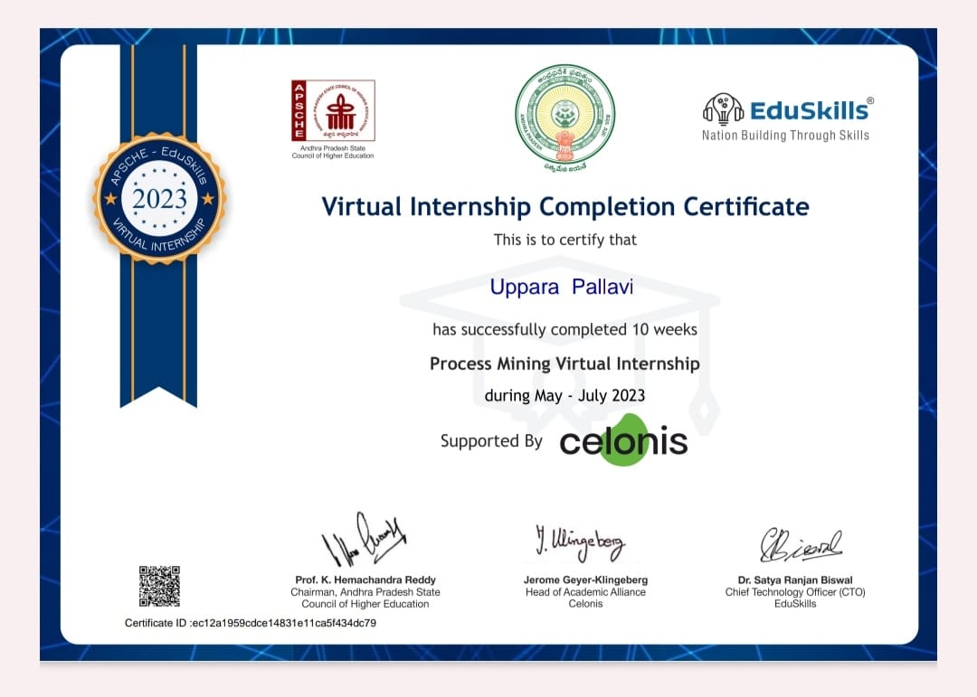
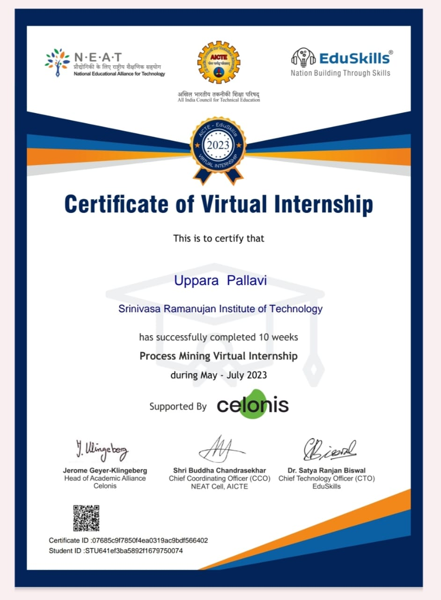
REFERENCES:
1. https://internship.aicte-india.org/
2. Process Mining | Celonis | The Leader in Process Mining

